21.12: a) 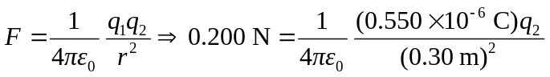
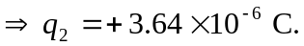
b) 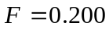 N, and is attractive.

